Growing Vocations in the Diocese of Leicester
In the Diocese of Leicester we are developing a culture of discipleship, expressed as Everyday Faith, which encourages all Christians into a deeper relationship with God that will enable the flourishing of individuals, churches and communities.
The vocation to live out our faith in all spheres of life is the calling of all Christians: rooted in our baptism and the commandment to love God and love our neighbour.
As we grow in depth of discipleship we can expect that increasing numbers of disciples will experience a sense of calling into fresh vocations as they grow in confidence in their gifts and are moved by God’s compassion for the world.
Vocation is not an individual enterprise but held within the wider vocation of the whole church to reveal the Kingdom of God and is expressed locally as each worshipping community seeks to fulfil its calling to their neighbourhood.

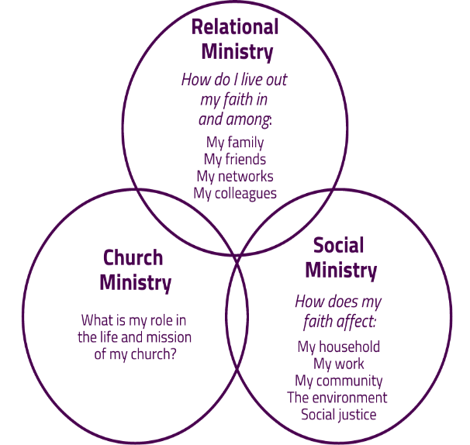

Many Christians are serving their local churches in a range of capacities crucial to building up the worshipping community. Some, however, are called to exercise particular ministries licensed or authorised by the church. As a diocese we seek to create a culture that grows all vocations particularly in underrepresented groups such as young people, those serving areas of deprivation, LGBT+, those with disabilities and people of UKME heritage. This strategy will set out how these aims might be achieved.
Values
- A culture of vocational development is at the heart of diocesan life.
- That worshipping communities discern their shared calling.
- All members are able to grow their own vocation within this shared calling.
- That diversity is represented in church leadership paying particular attention to:
  - Ethnicity
  - Younger people
  - Those from areas of deprivation
  - Gender
  - LGBT+
- That ministry is mutual and collaborative and all ministries are valued equally.
- There are clear vocations pathways that are accessible whilst applying the highest standards of Safer Recruitment

Ministry in the Diocese of Leicester
Authorised ministry in the diocese falls within 3 broad categories. Ordained ministers are discerned and trained nationally and are licensed within the Diocese. Associate Ministers are licensed lay ministers, discerned locally and at Diocesan level and trained through the diocesan training programme. Authorised Local Ministers are discerned and authorised in their local worshipping community but can access specific training provided by the diocesan training programme.
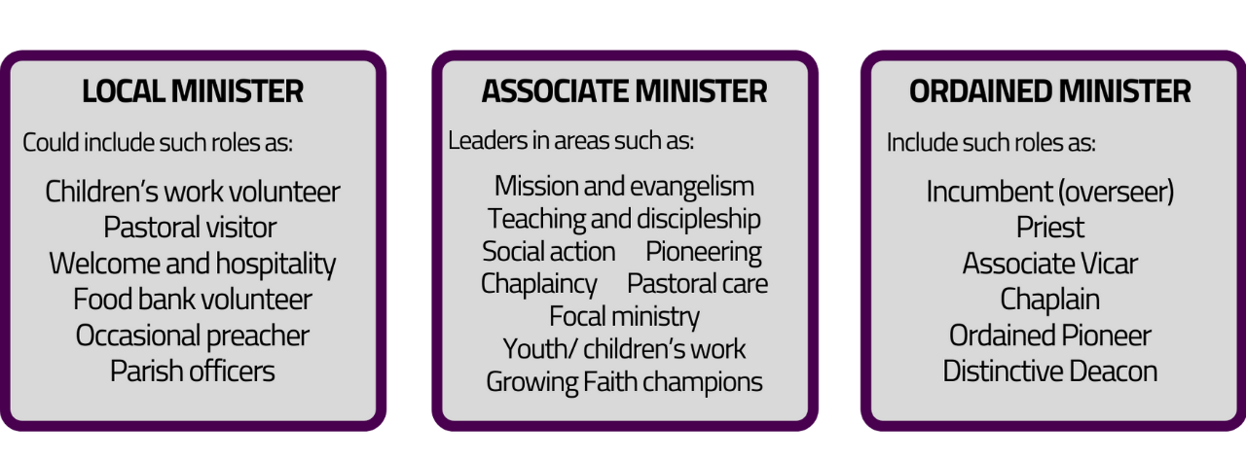

Licensed Associate Ministers
This section of the strategy outlines the scope of Associate Ministry, the discernment process, training programme and ongoing ministry development and support.

Scope of Associate Ministry
Associate Ministers will fulfil a range of ministries previously defined as Reader, Pioneer, Pastoral Assistant and Evangelist. The specifics of an individual’s ministry will be described in their Ministry Plan. Underlying characteristics of the ministry will be:
- Leadership – to be members of the local leadership team and lead others to deliver ministry
- Replication – to intentionally develop vocation in others

Discernment process
A prerequisite for discernment for Associate Minister is Journey in Faith Course, The Forge (Pioneer School) or equivalent. The discernment process has three elements and a Vocations Advisor will work with the candidate through the process.

Personal

Diocese

Local

- Personal – a Discernment Portfolio that explores their:
  - Faith journey
  - Spiritual life
  - Sense of calling
  - Strengths and weaknesses
  - Their context
- Local – a discernment by the local leadership team (PCC or equivalent) to assess:
  - Support of the candidates call to ministry
  - How this ministry fits within the calling of the worshipping community
  - How their ministry will be supported and resourced.
  - References
- Diocese – a discernment conversation based around the national lay discernment qualities.

Training
During discernment and training the candidates will be forming their Ministry Plan which will describe the specifics of their ministry. The training programme is comprised of two phases – Phase 1 is common to all candidates and can be summarised as:
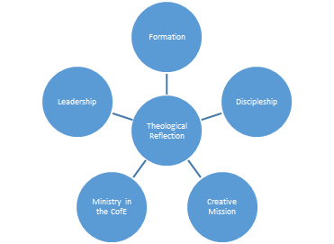
Phase 2 will be more flexible to equip candidates for the specifics of their ministry. Training will also include placement opportunities to broaden ministry experience.
The training will take 15 months followed by a probationary period before licensing.

Licensing
Having completed training candidates will be licensed as Associate Ministers under Canon E6. Licensing will take place at the annual Called Together service which will take place on the Satuday after Pentecost.
Licenses are renewed every three years after a review of the Ministry Plan with their supervisor which will include evidence Continuing Ministerial Development (CMD) undertaken and identify future learning needs. Ministers will also need to update their safeguarding training and DBS check before relicensing. Relicensing will take place at the Called Together Service.
Licensing of existing lay ministers
Existing lay ministers will continue to be relicensed under the terms of their original license every three years. Some may wish to be relicensed as Associate Ministers if this better describes the scope of their ministry (a copy of a role description can be found on the website). A transfer to an Associate Minister license should be agreed with:
- Their supervisor and have support of the PCC
- Discussed with the DVE and any training needs identified
- Agreed by the Sponsoring Bishop

Permission to Officiate
Previously ministers were required to surrender their license when they reached 70 years of age and could request the Bishop’s Permission to Officiate (PTO) to be renewed annually. From 2022 all lay ministers will remain on 3 year license renewals until they choose to retire from their ministry. Those already with PTO will only need to renew every three years.

Lay Ministry Council (working title)
The Lay Ministry Council will replace existing PA and Reader Council. It will be convened by the DVE and Chair with membership draw from the range of lay ministries and be representative of the diversity in the Diocese. The council will be accountable to Bishop’s Council and under the oversight of the Bishop of Loughborough. It will be responsible for:
- On-going development of the Growing Vocations Strategy and monitoring its implementation and effectiveness
- Generating a vision for lay ministry that will meet the needs of the emerging shape of ministry in the Diocese
- Creating adequate processes for ministry support and development
- Influencing the cultural shift towards mutuality of ministry and forming of multi-disciplinary teams
- Promotion of lay ministry and vocations throughout the Diocese
- To represent the voice and experience of lay ministers into Diocesan structures

Locally authorised Ministers
It is understood that many people serve churches and communities in a range of capacities who might not wish to be licensed as Associate Ministers. It is also hoped that Associate Ministers will grow teams of people to deliver particular areas of ministry. To recognise and affirm these roles may be important and for this reason local churches can discern and authorise roles that may include:
- Occasional preachers
- Pastoral Visitors
- Youth and children’s volunteers
- Food bank volunteer
- Parish officers
Local Ministry Assistants can access any training modules that may equip them for their role. While it is up to local churches to decide who and how they discern these roles, it should be remembered that anyone fulfilling any position of responsibility should undergo a Safer Recruitment process and have clear accountability and supervision. Authorisation can happen as appropriate to the context but a sample liturgy is available on the Diocesan website.

Ordained Ministry
This section outlines the discernment process for ordained ministry and training.

Discernment
Discernment for ordained ministry is going through the biggest changes for over 40 years with the aim of increasing accessibility whilst maintaining rigor.
Qualities are replacing criteria and a two stage process is replacing Bishops’ Advisory Panels (BAP). Candidates will work with the DDO or ADDO through the initial discernment phase before being recommended for Stage 1 and Stage 2 assessments.
Auxiliary Ordination Pathway
Those over 50 years of age and exploring Self-Supporting Ministry will join the Associate Minister discernment pathway and stage 1 training. They will be invited to a Local Assessment Panel to discern their call to ordination and then undertake additional modules of training to prepare them for ordination.

Training
Candidates recommended under the national process will then train for 1,2 or 3 years at a Theological Institution. Those recommended under the Auxiliary will train on the diocese provided courses.

All candidates will then serve curacies; the length determined by their pathway and their needs.

A summary of discernment pathways can be found in the appendix.

Strategy
Our approach to vocation is to enable the flourishing of God’s people, fruitfulness for our churches and blessing the world. We recognise that the local worshipping community is the context in which vocations should be grown and nurtured. The role of the diocese is to encourage and resource this process, share stories and celebrate God at work among us, communicate our shared values and facilitate the process for discernment, training and ongoing support for ministry.
Intervention |  | Outcome
Value 1 | Developing a culture of vocation in the Diocese
- Vocational questions embedded into all aspects of Diocesan life  - Growing vocations in others to form part of MDR questions  - Ensuring vocations stories are shared across the Diocese.  - Ensuring diversity is represented at all levels of Diocesan life  - Local Vocations Champions – in each Deanery |  | - A rise in the number of stories of Christians responding to God’s call.  - Visibility of BAME and young leaders
Value 2 | That worshipping communities discern their shared calling.
- Support churches and Mission Units to discern their shared calling |  | - A rise in the number of churches and Mission Units seeking support to discern their calling
Value 3 | All members are able to grow in their own vocation
- Encourage and enable Everyday Faith conversations.  - Encourage participation in The Forge and Journey in Faith  - Local vocations events  - Network of Vocations Champions in each new Mission Unit |  | - An increase in requests for vocational conversations.  - An increase in vocations to licensed ministries.
Value 4 | That diversity is represented at all levels of leadership in the diocese.
Growing UKME Vocations
- Raise awareness among existing leaders to the barriers facing UKME Christians in the vocations process.  - Diversity represented among ADDOs and Vocations Advisors.  - Provide targeted, local vocations events.  - Provide mentors and ‘Safe Spaces’ for candidates of UKME heritage.  - Ensure discipleship material (eg. JiF and Forge) are more globally representative. |  | - Visibility of UKME leaders  - Visibility of diversity at all levels of Diocesan life  - Increase in numbers of UKME candidates  - Stories of ministry among UKME Christians.
Growing young vocations
- Investment in discipleship among young people  - Vocation embedded into programmes for children and young people  - Provide mentors and ‘Safe Space’ for nurturing leadership in young people.  - encourage opportunities and permission for young people to exercise ministry  - training for local contexts in discipling young people |  | - Decrease in the age profile of those coming for discernment.  - Stories of young people exercising ministry.
Value 5 | That ministry is mutual and collaborative and all ministries are valued equally.
- Training for clergy, ordinands and lay ministers in mutuality of ministry  - Model collaborative ministry at all levels of Diocesan life especially at key moments such as Called Together  - Ensure Lay and Ordained ministries are equably represented.  - Work with local contexts to encourage a culture of shared ministry |  | - Positive stories of collaborative ministry  - Evidence of parity in how different ministries are represented.
Value 6 | That there are clear pathways for vocation
- Review the new lay discernment pathway  - Recruit, train and resource the Vocations Advisors  - Implementation of new Ordained discernment pathway |  | - Positive feedback from candidates.

Vocations Team Structure

Vocations Team
DDO, DVE, HLMD
ADDOs
Training

Lay Ministry
Council
Vocations
Champions
Vocations Advisors

Ordination
Continuing Ministerial Development
Local
Authorisation
Licensing
Local
Panel
Local
Discernment
Diocesan Training
Diocesan Discernment
National Training
National Discernment
Incumbent
Vocations
Advisors
DDO/ ADDO
Local Minister
Associate Minister
Ordained Minister
Auxiliary Ordination
> 50 SSM
Ministry Discernment Process
Personal discernment
What is God saying? What do others say? What does my heart say? What does my head say?
Referral to Vocations Team

