2022 Deacons – Info for Order of Service

Mark Batchelor  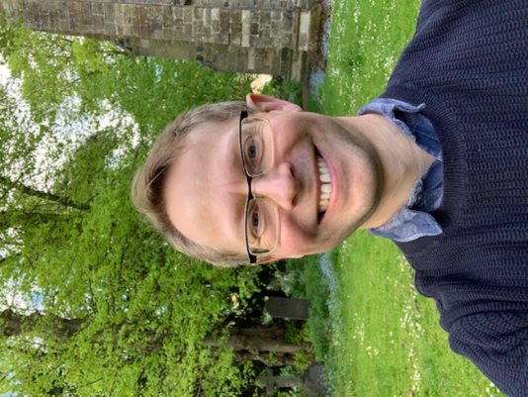 | Before answering a call to ministry, I was, among other things, a geography teacher, teaching in Wigston for many years and loving being involved with many aspects of school and community life. My wife and I originally met as students at Leicester University and have stayed in Leicester ever since, bringing up our three, now nearly all adult, children. I’d thought everything was settled, but isn’t it great when God won’t let you alone? I’m now so excited to be fully immersed in the life of St. Denys Church as it brings the love of Jesus to the Evington community.
Matt Green  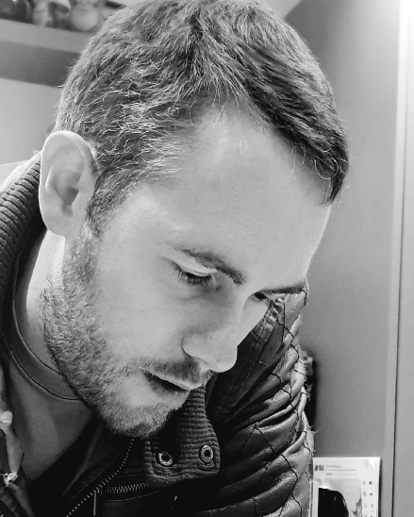 | Before Training as an ordinand Matthew was a teacher at a SEND school. Alongside this he, and his wife Mary, worshiped and worked at their local church running the children and family ministry. Through this Matt discerned a calling to work for the church fulltime, which developed into a calling into fulltime ordained ministry. Having spent 3 years studying in context at St Mellitus College East Midlands, and in a placement at St Mary in Charnwood, Nanpantan Matt has been able to tie his theological learning and practical elements of ministry together. As he looks forward towards his curacy in Castle Donington he is most excited about the missional opportunities a new context will provide, and the ways in which worshipping God outdoors might present themselves.
David Lewis  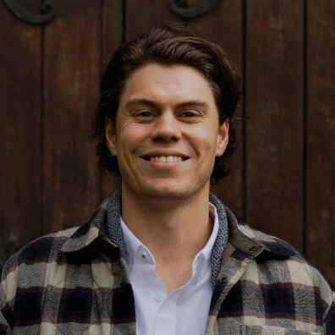 | I started attending church at the age of 8. My love for musical worship led to an internship at St Aldates Church and then a job at Holy Trinity Leicester as a musical director. After that I was a manager at DMU, then CLC Bookshop, then Sir Jonathan North College. I’m now about to become a Church Planting Curate for St John the Baptist Church and I am really excited to reach people with the Gospel. I am married with four children. My main hobbies are playing guitar/singing, supporting Leicester Tigers, fantasy fiction, and somehow getting back into shape!
Kat Marjoribanks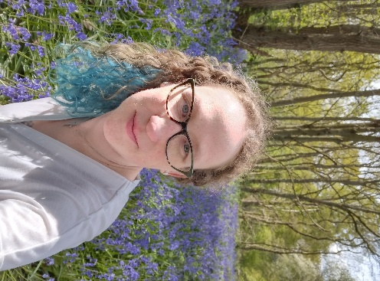 | I trained for ordination at St Mellitus College- initially in London and then transferring to Nottingham when their East Midlands Centre opened. I had two children at the start of training, and three now! My journey to ordination was a long one; I pretty much stuck my fingers in my ears for over a decade, but God doesn't give up and here I am! Having initially started the process out of obedience to God (but with slightly gritted teeth) I have come to know myself so much more and understand the calling God has for me. I love Jesus' Church so very much and I am excited about going where God leads me next.
Sharon Plant  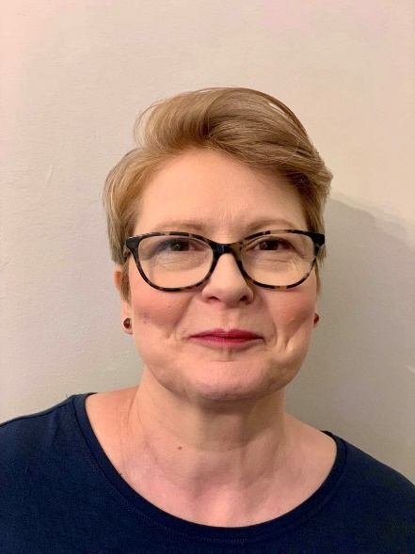 | I’m married to Matt and we have two grown-up sons, Joel and Cameron – who is engaged to Harriet- and we have a dog called Chip. In my spare time I love to garden and to craft.  Lay ministry has always gone alongside my working and family life, culminating with my last role as a church Youth Worker. My passion has always been to share and receive the abundance of God’s love and grace in the community, and I’m looking forward to that continuing in my curacy. The Pioneer ministry training I’ve received from the Church Mission Society has really prepared me for that.
Phillippa Taylor  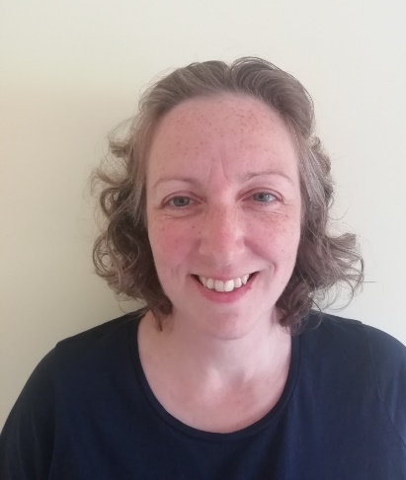 | I am married to Jim and we live with our cat Basil. I was introduced to faith by my Mum as a baby and have always been involved with church life, serving in many different roles over the years, but it took me a long time to hear God’s call to ordained ministry! I trained on a contextual programme at St Hild College in Sheffield, which was combined with a placement at St Botolph’s, Shepshed and St James, Oaks-in-Charnwood. I am really looking forward to serving my curacy at the Church of the Martyrs and meeting new people there.
Riffat Zamurad  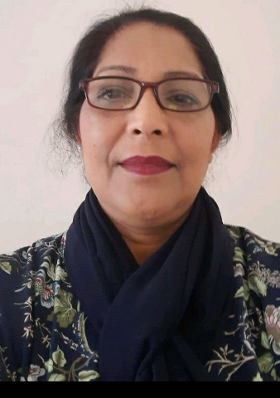 | Growing up in a small village in Pakistan, me and my three sisters were brought up by my Father who was a devout vicar and my Mother who was a School teacher. At the age of 12 I was sent to a Christian boarding School, where I experienced a supernatural encounter with God. I grew up to work as a nurse and eventually came to the UK. Seeing closed Churches was a great shock and broke my heart, but this was great motivation to some day go into ministry. Years later with my husband and three children together serve the Lord.

