
Creating a Curate’s Learning Development Plan

As part of your Curacy planning for the year ahead please create a learning development plan to focus and support your learning over the next 12 months.

Using the template that follows, fill in your first thoughts and send it to your TI before you will then discuss it together. After the meeting update the Plan with any necessary changes and send a copy to the Vocations and Training Administrator for review and approval by the IME2 Officer and/or Head of Vocations

How to fill in the Learning Development Plan

Research shows that lasting learning comes in 3 ways.
- 10% comes from formal education (courses, books etc)
- 20% comes from learning with others
- 70% comes from experience and reflection

The chart below illustrates this and offers some ideas for learning for each of the ways

Also below is a worked example of a Curate’s Learning Development Plan followed by a blank template for you to use.

Start with 3 areas that you have identified for your learning. Write these in the left hand column (one in each box). Then work across outlining what you will do to achieve this. You do not have to have something in the 10% formal education column as this may not be the most appropriate way to learn a new skill. There should be something in all the other columns. Try and focus on the best way for you to learn.

If you would like help, then please contact the IME2 Officer or the Head of Vocations.

June 2026
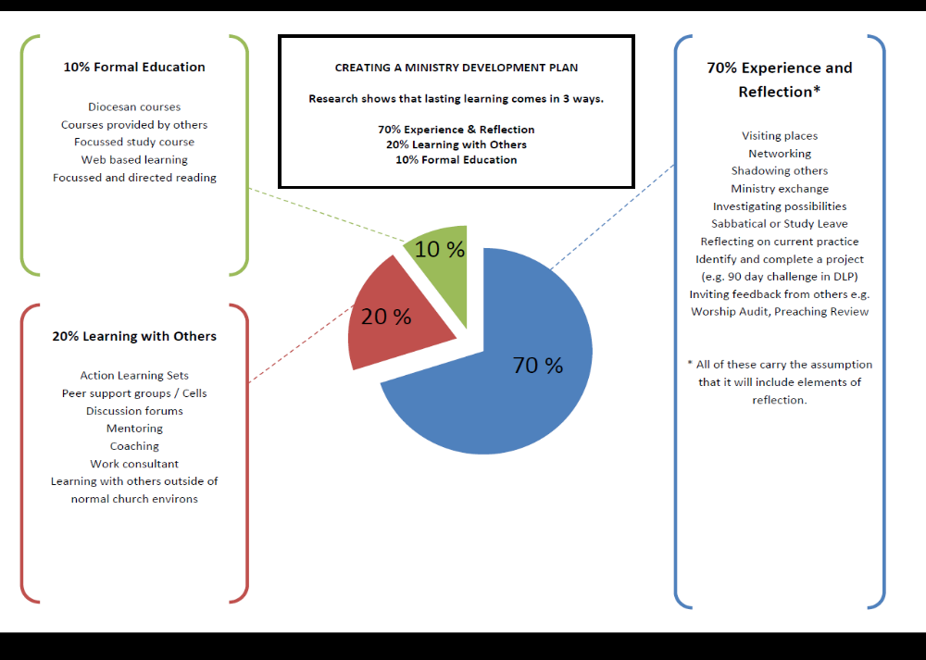
Learning Development Plan – worked example

What do I want/need to learn? | What will I do to achieve this?  Formal Education 10% | What will I do to achieve this?  Learning with Others 20% | What will I do to achieve this?  Experience and Reflection 70% | What resources or support will I need? | When will I complete this?
To improve the quality and impact of my preaching | Directed reading on homiletics, particularly sermon construction.  Increase awareness of cultural shifts – source a relevant course | Arrange a ‘Preaching development’ consultation with PTMD, for all who preach in my location. | Video myself preaching : Reflect and learn through group feedback.  Identify, map and produce a summary of local cultural shifts and developments since the beginning of my ministry here. | PTMD dept for consultation  Resources to listen to others sermons – podcasts  A cultural guide – fresh eyes! | Over a three – 6 month period. By July 2020.
To work on my spiritual practices (holy habits) to sustain me in ministry | Attend the session on Holy habits in January 2020 | Set up a small group to work on this topic following the session.  Review after 3 months. | Use a reflective journal to notice how my holy habits are changing. Update weekly.  Introduce one new spiritual practice and reflect on the impact | Others who have different practices to me  PTMD dept for consultation | Over the next year. Review in 6 months and after a year.
To develop my ability handle conflict better |  | Meet with an experienced colleague to talk through conflict conversations and explore learning. | Invite feedback on how I am handling conflict. | Skilled colleagues to reflect with. | Ongoing. Review in mid 2020.
Curate Learning Development Plan

Name: Date From: Date To:

What do I want/need to learn? | What will I do to achieve this?  Formal Education 10% | What will I do to achieve this?  Learning with Others 20% | What will I do to achieve this?  Experience and Reflection 70% | What resources or support will I need? | When will I complete this?

If you would value a conversation, or a consultation about the discerning and forming of a learning plan please contact IME2 Officer or the Head of Vocations.
June 2026

