
Access And Disability Audit Report

Note: This document gives general guidance and prompting regarding physical accessibility of a church building. Ideally these conversations will be had with a small group including an individual(s) with lived experience of disability, the incumbent or minister and person(s) with leadership responsibilities for different areas of church life. This guide is designed to begin conversations and start your journey towards being accessible before a formal Access Audit is carried out.

Before you begin, remind yourself what a disability is. It’s much broader than we often think. The Equality Act defines disability to be a physical or mental impairment that has a substantial and long term negative effect on a person's ability to do normal day-to-day activities. Substantial meaning more than minor, so it might take someone much longer than it usually would to do a common day to day activity such as getting dressed. Long term is it lasting or that it will last for longer than 12 months. It is also worth noting that under the Equality Act we have an anticipatory duty when it comes to disability inclusion.

Church Building:

Date:

Persons present doing audit:

1 | Reason for audit. What do you hope to achieve?
2 | Describe the church in general; community, congregations, user groups, service styles etc.

3 | Any current issues, concerns or projects?
4 | How does someone find your church? External signage, visibility from road, directions/info on website.
5 | Car Parking; what provision is there for cars/bikes/motorbikes, how much, how do you get from parked car to main entrance?
6 | Approach to the church; describe the path, is their lighting, is it level or sloped, clear from obstruction, are there any steps, what’s the surface under foot etc.

7 | Entrance; is it clearly visible, steps/slopes, handrails, wheelchair access, pushchair access, signage, welcomers at every service? etc.
8 | Lighting; internal and external, lighting type (eg LED), dark spots, buzzing, flickering etc.
9 | Hearing Loop; is there one in working order? Does it cover the whole space?
10 | Seating & Flooring; movable or raised seating, seat material, space for wheelchair/powerchair user, seats flush with floor, floor surface(s), any seating with arms etc.

11 | Moving around inside the building; are there any pinch points of traffic? Are there internal level changes or steps? Any handrails? Could a wheelchair user access the alter, font, lectern etc.
12 | Screens/Printed materials; what is used during service? Large copy available? Dyslexia friendly colours, font sizing? etc.
13 | Toilets; how many? Where? Is there a disabled toilet? Is it clear of clutter? baby change facilities? Clear directional signage? etc.
14 | Kitchen or servery; where is it? How are people served refreshments? How is it accessed? Etc.

15 | Are there any other church buildings? Has a similar audit been done there?
16 | Notice Boards and signage; is there a main notice board (inside or out)? Is it clearly visible? Info up to date? Safeguarding info displayed? Internal directional signage?

Any other notes:

If you have any questions about anything in this document or would like any advice regarding accessibility in your church then please contact the disability advisor on: emily.williams@leicestercofe.org

Potentially Helpful Resources

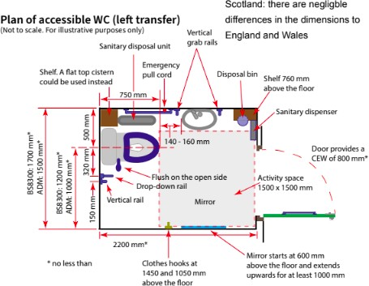

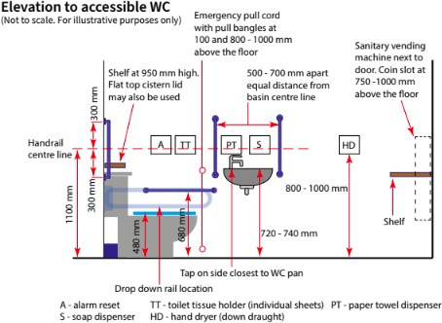

- Above are two images that will hopefully help you assess the accessibility of your disabled toilet. Moreability also have helpful information: https://www.moreability.co.uk/help-advice/2018/08/disabled-toilet-size

- There is information about Wheelchair Ramp Regulations and Compliance here: https://www.wheelchair-ramps.co.uk/special/disabled-access-regulations-dda/

- The church of england have a Barrier Free Belonging page with other helpful resources on too: https://www.churchofengland.org/resources/barrier-free-belonging

*source acknowledgement and links does not indicate company endorsement

